How to stage Junos SW
1 Introduction 2
2 Prerequisites 2
3 Step-by-step plan 3

Introduction
This manual is intended as guide for staging an EX switch

Prerequisites
Filled in xls Template file
Console cable
Latest firmware version (Meso)

Step-by-step plan
- Take the needed amount of switches and Physically Connect the switches by using the DAC-cables ( or SFP’s with fibres ) on the correct ports.
DAC-cable ( directly attached cable ): 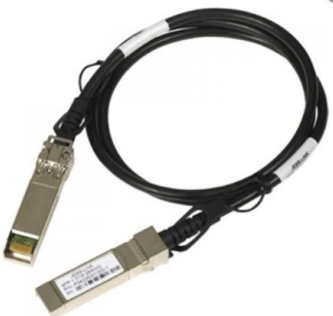
VC ports on the EX 3300 are the SFP ports on the front of the switch at the right side, port number 2 and 3
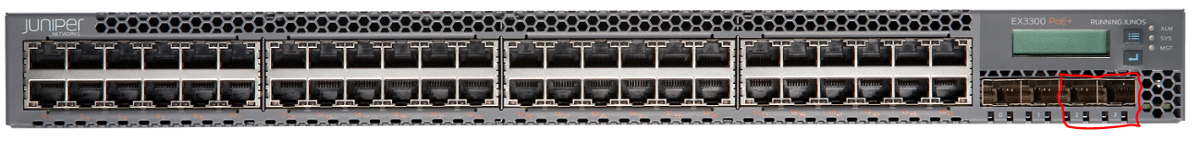
The goal is to create a circle of switches (even with 2 switches 2 cables should be used):
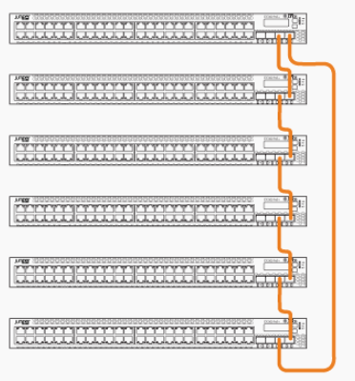
- Boot one switch first, wait 1min then boot all other switches (connect power cable)
- Prepare an usb stick with both the configuration file and the latest Junos version. (cf manual Junos FW/SW template)
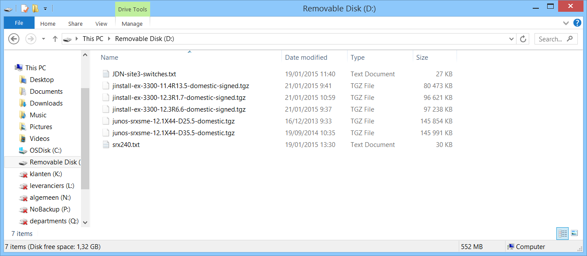
- Connect the serial console cable to the switch you booted first
EX3300: On the back of the device, the RJ45 port marked “CON”
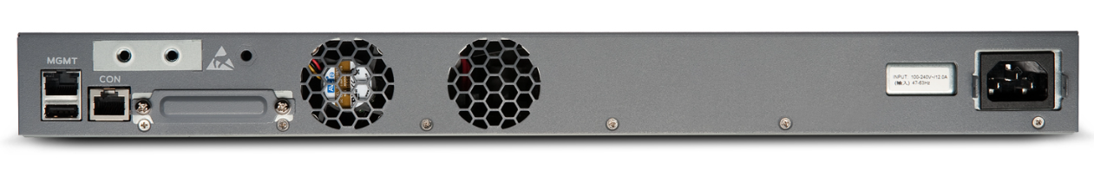
- Boot the EX and track its progress via the console. The boot is completed when you see the login prompt:
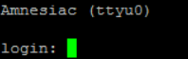
- Login with the username “root” and no password (you will not be prompted for a password)
You will get a new prompt
- Plugin the USB stick
The usb port is also located on the back of the device next to the console port (see picture above).
When properly connected you will see input in your console:
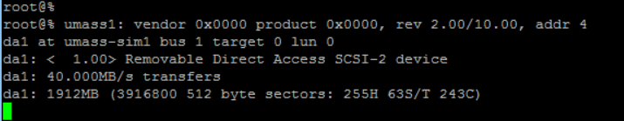
- Mount the usb stick with the following command:
mount –t msdos /dev/da1s1 /mnt
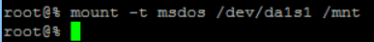
- Copy the files to the temp directory:
cp /mnt/<filename> /var/tmp
(Do this twice: once for the junos package, once for the config file)
- Check if the file are properly copied:
ls /var/tmp
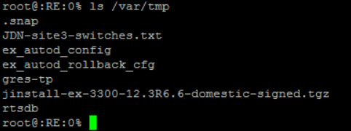
- Unmount the usb stick:
umount /mnt
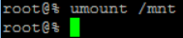
- Unplug the usb stick
- Go into operational mode:
cli
Again you will see a new prompt
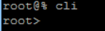
- Upgrade the software on the EX
Request system software add /var/tmp/<name of junos package> reboot
This command will take a while to complete since it will distribute and install the software on all switches and then reboot the systems.
The output should be something like:
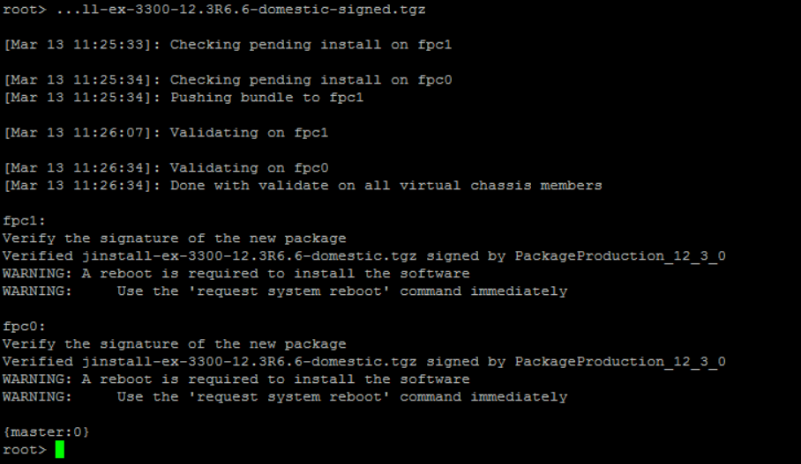
- Wait for the systems to come up again.
- Login with the root user (still no password)
- Go into cli mode :
cli

- Verify the VC is running properly:
Show virtual-chassis
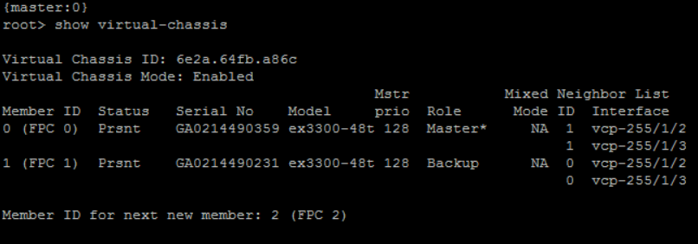
The above ouput show an operational VC, if the status of some members is not present then the VC is not yet fully operational and you should wait a bit.
- Copy the junos package to the backup partition:
Request system snapshot slice alternate all-members
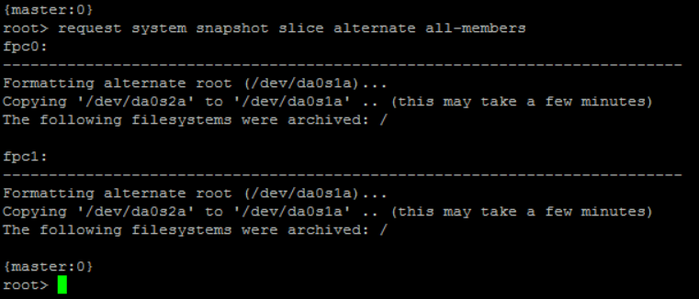
This command does take a “while” to complete
- Check if both partitions have the same and correct version installed:
show system snapshot media internal all-members
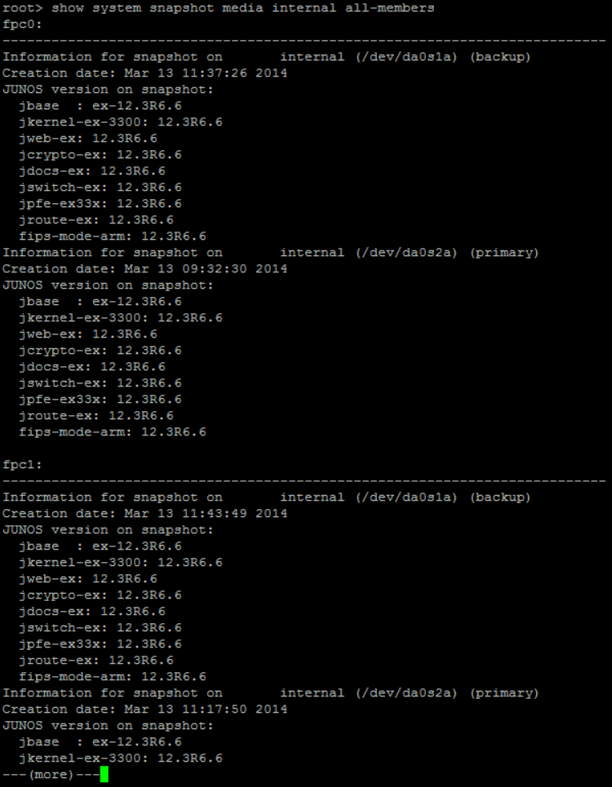
- Go into configuration mode:
edit
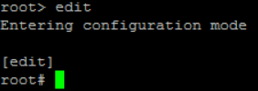
- Load the config file:
First Possibility :
Load set /var/tmp/<config-file-name>
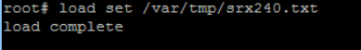
There should be no other output then the above, if there is other output an error has occurred and must be attended to before sending the device out!
Second Possibility:
Load set terminal
You can copy the contents of the configuration file.
Paste it in the terminal window by right-clicking.
Close the terminal editor bij entering “Ctrl-D”.
- Add the adl_tse user configuration. In the xls template you can find the commands to create the user in tab “F2”.
First copy
set system login user adl_tse uid 2002 class super-user authentication plain-text-password
When asked copy the password
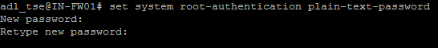
- Commit the config file:
Commit synchronize
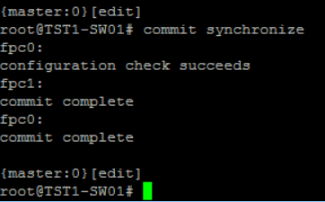
- Check if the interfaces received their correct IP addresses:
Run show vlans
Check if the interfaces are properly assigned (cf Port assignment Junos EX switch):
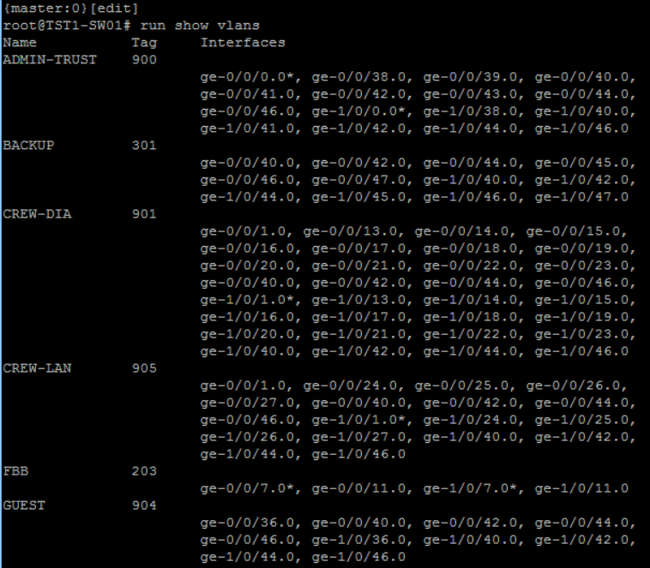
- Ignore chassis alarm warning
set chassis alarm management-ethernet link-down ignore

- Return to the cli
exit

- Set up idle cli timeout
set cli idle-timeout 10
- Create a rescue config
request system configuration rescue save
- Properly shutdown the switch
Request system power-off all-members

